## Activity entrance application

The purpose of this application is keep track of all the visitors that enter a given activity. It features reserved places tracking, free to enter places tracking. It interacts with the database and validates all the data of visitors that are entering current activity and notifies the worker operating the computer.

Finctionality and user expirience:

1. The user starts the app and choosees the activity that is he going to be incharge of at the given moment. What you can see is that data about the selected activity is being populated to the form, which serves as аn informational mean for the user.
2. After he opens the reader and scans some of the chips, he can see that the data about the given bracelet is populated on the form.
3. The next step is to click the proceed button which is going to execute several methods and queries. That is going to result the entrance of the current visitor.

General structure and organisation:

The application consists of two forms connected to each other.

Here can be seen the structure of DBHelper class it is used to interact with the database.

The fields in the class serve as temporary holders of the values used in the method executions

The specific about the structure of the class is that it is divided into two kind of methods:

* Methods that return a mysql command
* Methods that execute these commands and return the retrieved data which is being attached to the visual part of the form afterwards.

The methods that are more specific are the ‘Entrance’ and ‘VerifyData’.

* ‘VerifyData’ acts as a protection against users who are trying to enter illegaly using the history table(it is described in the database specifications)
* ‘Entrance’ executes all the main queries for manipulate the seat numbers.

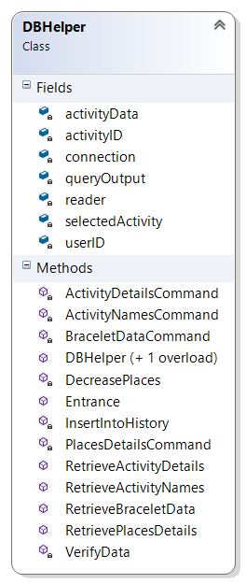

## Activity exit application

The purpose of this application is keep track of all the visitors that exit a given activity. It interacts with the database and lowers the current number of visitors.

Finctionality and user expirience:

1. The user starts the app and choosees the activity that is he going to be incharge of at the given moment. What you can see is that data about the selected activity is being populated to the form, which serves as аn informational mean for the user.
2. The next for the user is to make sure a bracelet is scanned and click the button ‘proceed’ which is going to execute the relevant queries.

Here can be seen the structure of DBHelper class it is used to interact with the database.

The fields in the class serve as temporary holders of the values used in the method executions

The specific about the structure of the class is that it is divided into two kind of methods:

* Methods that return a mysql command
* Methods that execute these commands and return the retrieved data which is being attached to the visual part of the form afterwards.

